
School of Science and Technology

Electronic Devices and Materials Technology ENGG10031
Academic Year 2022-2023

  - Lab 2: Diodes I

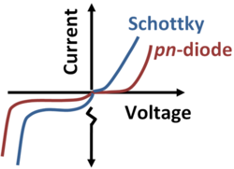

Objectives
- Obtaining characteristic curves of diodes (silicon, germanium)
- Comparing the characteristics and applications of different types of diodes

Equipment and materials
- Breadboard
- Digital Multimeters (Keithley 2110-240)
- Variable DC power supply (Keithley 2331A-30-3)
- Resistor 100 Ω (2W); Alternatively, 2 Resistors 220 Ω (1W) in parallel connection
- Silicon diode (1N4148), Germanium diode (1N34A)
- Connection leads

Required information

Diode characteristics
There are various types of diodes available in the market. Characteristic curve of a typical diode is shown in Figure 1. In this lab, you are going to acquire voltage and current readings for plotting the characteristic curves of 2 different types of diodes.
Figure 1. The characteristic (approx.) curve of a typical diode

Diode Pin Out Orientation
The diodes used for this experiment and their respective pin-out orientations are shown in Figure below. Generally, diodes are marked with a coloured band that denotes the negative pin.
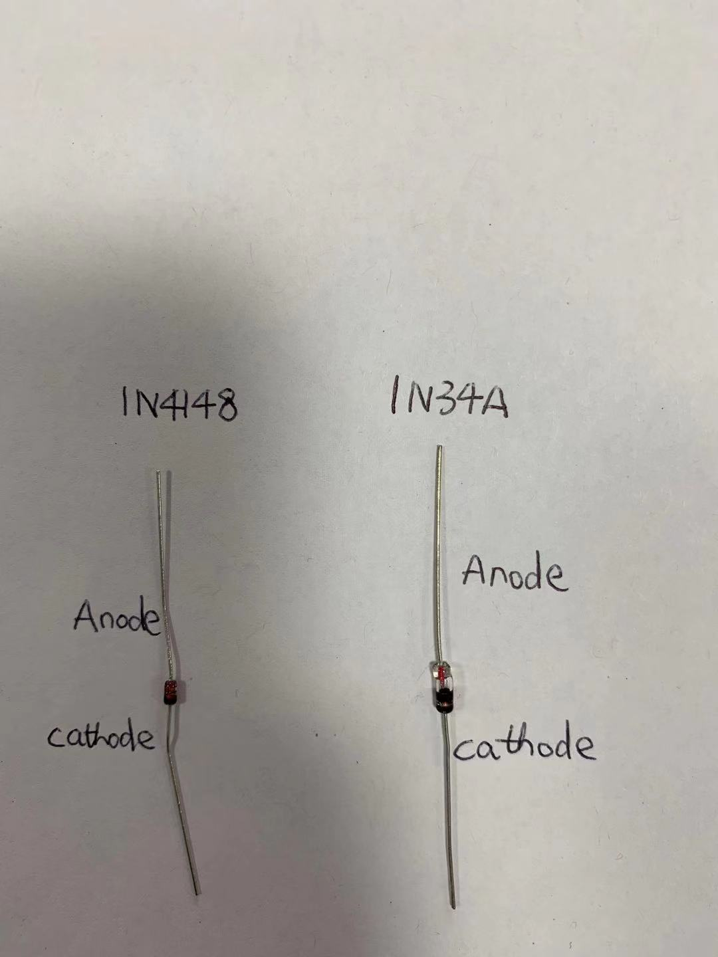
Figure 2 Photo of the diodes

Diode data sheets.
The diode datasheets can be downloaded from the NOW learning room (Week 11 Diode I->activity). They can also be found at the following web sites.
1N4148: https://docs.rs-online.com/7006/0900766b8170974e.pdf
1N34A: https://www.tme.eu/Document/0a9524ad7e11ca40773ed52e579d7546/1N34A.pdf

Laboratory procedure

Characteristics of silicon, germanium diodes
In the experiment, a silicon and germanium diode will be tested separately to produce voltage and current data that will be used to plot the I/V characteristics curve of the diode. To produce the data, a test circuit will be constructed using the breadboard. The test circuit will be powered by a DC power supply. Test equipment consisting of DMM will be used to measure the following parameters:
- Circuit input voltage (V_{in})
- Voltage drop across the diode (V_{d})
- Current through the diode (I_{d})
- Examine the diodes and identify their anode and cathode. The cathode is indicated by the silver polarity band. The anode is connected to the p-type silicon and cathode is connected to the n-type silicon.
- Check the datasheet of the diodes and fill in the table below.
 | wattage rating | maximum DC forward current | Peak reverse voltage
1N4148 (silicon diode)
1N34A (germanium diode)

- Construct the circuit shown in Figure 3 with the silicon diode 1N4148. Connect the circuit so that the diode is forward biased with the anode toward positive supply terminal and cathode toward negative supply terminal.
Figure 3. Circuit for obtaining input characteristics of the diode.
- Click on “I-Set” of the power supply, set the values to be 100mA. Click on “V-Set” of the power supply, set the values to be 0V. These settings will set the power supply as a constant voltage source and limit the current of the circuit to be 100mA.
Turn on the power supply. Using arrows on the power supply to change the digits to be the first digit after the dot. Increase the voltage of the power supply slowly using the knob so that you get a diode current of 100 mA. For your own safety and to protect the test equipment, do not exceed 100 mA. In table 1, record both the voltage of the power supply and the voltage across the diode at this current. Note that the DMM should be connected parallel to the circuits for voltage measurement. Click on “DCV” to set the DMM to measure voltage. Use the top right red port and right black port for the voltage measurement.
Decrease the supply voltage using the knob until the diode current is 50mA. Record the diode voltage at this current in Table 1. Repeat this process for diode currents of 20mA, 10mA, 5mA, 2mA and 1mA.
Continue decreasing the supply voltage so that you achieve diode voltages of 0.5V, 0.25V and 0.1V. Record the diode currents at these voltages in table 1 also. Note that the DMM should be connected in series to the circuits for current measurement. You can do this by removing the wire that connects the resistor and the diode and replacing it with the DMM. Click on “SHIFT” and then “DCV” to set the DMM to measure current. Use the white “3A” port and right black port for the current measurement.
- Turn off the power supply and reverse the + and – leads of the power supply where they connect to your breadboard. Now the diode is reversed biased. Slowly change the diode voltage in -2 V steps from 0 to -10 V and record the resulting current in Table 1.
Table 1 Measurement of the I/V characteristics of a silicon diode
V_{d} (V) | I_{d} (mA) | V_{in} (V) | power (W_{d}=I_{d}×V_{d})
 | 100
 | 50
 | 20
 | 10
 | 5
 | 2
 | 1
0.5
0.25
0.1
0
-2
-4
-6
-8
-10
- Repeat the procedures 3-5 with a germanium diode. Make sure you do not exceed the wattage rating for the diode. Fill in the Table 2 below.
Table 2 Measurement of the I/V characteristics of a germanium diode
V_{d} (V) | I_{d} (mA) | V_{in} (V) | power (W_{d}=I_{d}×V_{d})
 | 100
 | 50
 | 20
 | 10
 | 5
 | 2
 | 1
 | 0
0
-2
-4
-6
-8
-10

- Use the excel to plot excel scatter graphs of your I/V data for the diodes tested. Make sure all graph exes are labelled properly and the graph has a proper title.

Discussion questions:
Silicon diode:
- What is a silicon diode? How does it work? What is it made of?
- What are reverse and forward bias?
- At approximately what voltage does the silicon diode begin to conduct any appreciable current (≈1 mA)?
- After the silicon diode begins to conduct appreciable current, what is its approximate average resistance?
- What is the purpose of the resistor R1 in series with the diode?
- What is the most current that could flow through the silicon diode in the test circuit if Vin was set at 30V.

Germanium diode:
- At approximately what voltage does the germanium diode begin to conduct any appreciable current (≈1 mA)?
- After the germanium diode begins to conduct appreciable current, what is its approximate average resistance?
- What is the most current that could flow through the germanium diode in the test circuit if V_{in} was set at 30V.

